**CSE 370 – Database Systems**

**Assignment 01 Sample Solution**

**Spring 2024**

**Question 1 [CO2] : 10 Points**

**Suppose that a database is needed to keep track of student enrollments in classes and students’ final grades.**

**The university is organized into colleges (COLLEGE), and each college has a unique name (CName), a main office (COffice) and phone (CPhone), and a particular faculty member who is dean of the college. Each college administers a number of academic departments (DEPT). Each department has a unique name (DName), a unique code number (DCode), a main office (DOffice) and phone (DPhone), and a particular faculty member who chairs the department. We keep track of the start date (CStartDate) when that faculty member began chairing the department.**

**A department offers a number of courses (COURSE), each of which has a unique course name (CoName), a unique code number (CCode), a course level (Level: this can be coded as 1 for freshman level, 2 for sophomore, 3 for junior, 4 for senior, 5 for MS level, and 6 for PhD level), a course credit hours (Credits), and a course description (CDesc). The database also keeps track of instructors (INSTRUCTOR); and each instructor has a unique identifier (Id), name (IName), office (IOffice), phone (IPhone), and rank (Rank); In addition, each instructor works for one primary academic department.**

**The database will keep student data (STUDENT) and stores each student’s name (SName, composed of first name (FName), middle name (MName), last name (LName)), student id (Sid, unique for every student), address (Addr), phone (Phone), major code (Major), and date of birth (DoB). A student is assigned to one primary academic department. It is required to keep track of the student’s grades in each section the student has completed.**

**Courses are offered as sections (SECTION). Each section is related to a single course and a single instructor and has a unique section identifier (SecId). A section also has a section number (SecNo: this is coded as 1, 2, 3, . . . for multiple sections offered during the same semester/year), semester (Sem), year (Year), classroom (CRoom: this is coded as a combination of building code (Bldg) and room number (RoomNo) within the building), and days/times (DaysTime: for example, ‘MWF 9am-9.50am’ or ‘TR 3.30pm-5.20pm’— restricted to only allowed days/time values). (Note: The database will keep track of all the sections offered for the past several years, in addition to the current offerings. The SecId is unique for all sections, not just the sections for a particular semester.) The database keeps track of the students in each section, and the grade is recorded when available (this is a many-to-many relationship between students and sections). A section must have at least five students.**

**Draw an ER Diagram which meets the above requirements. Use regular notation to denote relationship structural constraints (Cardinality Ratio and Existence Dependency Constraint). State clearly any assumptions you make.**

**Question 1 Answer:**

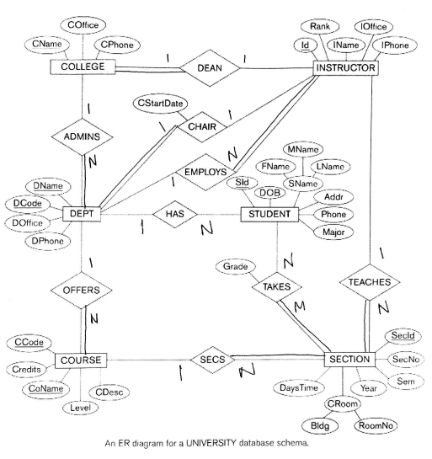

**Question 2 [CO2] : 10 Points**

**Design a database to keep track of information for an art museum. Assume that the following requirements were collected:**

**● The museum has a collection of ART_OBJECTS. Each ART_OBJECT has a unique Id_no, an Artist (if known), a Year (when it was created, if known), a Title, and a Description. The art objects are categorized in several ways, as discussed below.**

**● ART_OBJECTS are categorized based on their type. There are three main types—PAINTING, SCULPTURE, and STATUE—plus another type called OTHER to accommodate objects that do not fall into one of the three main types.**

**● A PAINTING has a Paint_type (oil, watercolor, etc.), material on which it is Drawn_on (paper, canvas, wood, etc.), and Style (modern, abstract, etc.).**

**● A SCULPTURE or a statue has a Material from which it was created (wood, stone, etc.), Height, Weight, and Style.**

**● An art object in the OTHER category has a Type (print, photo, etc.) and Style. ● ART_OBJECTs are categorized as either PERMANENT_COLLECTION (objects that are owned by the museum) and BORROWED. Information captured about objects in the**

**PERMANENT_COLLECTION includes Date_acquired, Status (on display, on loan, or stored), and Cost. Information captured about BORROWED objects includes the Collection from which it was borrowed, Date_borrowed, and Date_returned.**

**● Information describing the country or culture of Origin (Italian, Egyptian, American, Indian, and so forth) and Epoch (Renaissance, Modern, Ancient, and so forth) is captured for each ART_OBJECT.**

**● The museum keeps track of ARTIST information, if known: Name, DateBorn (if known), Date_died (if not living), Country_of_origin, Epoch, Main_style, and Description. The Name is assumed to be unique.**

**● Different EXHIBITIONS occur, each having a Name, Start_date, and End_date. EXHIBITIONS are related to all the art objects that were on display during the exhibition.**

**● Information is kept on other COLLECTIONS with which the museum interacts; this information includes Name (unique), Type (museum, personal, etc.), Description, Address, Phone, and current Contact_person.**

**Draw an EER schema diagram for this application. Discuss any assumptions you make, and then justify your EER design choices.**

| **Question 2 Answer:** |
| --- |